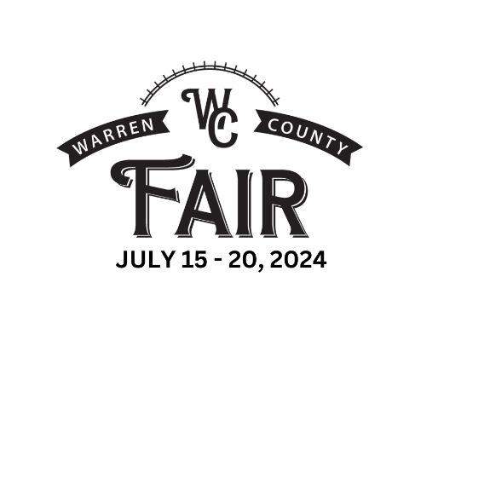
2024 LITTLE MISS and MISTER
Entrant Number

Office Use Only
WARREN COUNTY FAIR
NEW – two nights of events!
Tuesday, July 16 & Thursday, July 18
(6 mos. – 3 yrs.) (4 yrs. – 8 yrs.)

On Tuesday and Thursday, registration will open in
the Event Center at 4pm. The Contest begins at 5pm!

Registration Form $5.00 entry fee
Please mail your entry form & payment to: Warren County Fair, PO Box 58, Lebanon, OH, 45036
or bring it with you to the Registration Table in the Event Center on the day of the program.
Entries can be made online with credit card: https://www.fairentry.com/Fair/SignIn/18545

CHILD’S NAME: ___________________________________________________________
Pronunciation (if necessary): ________________________________________________
Thursday:
Little Miss/ Mister Age 4
Little Miss/ Mister Ages 5 AND 6
Little Miss/ Mister Ages 7 AND 8
Tuesday:
Little Miss/ Mister 6m-11m
Little Miss/ Mister 12m-23m
Little Miss/ Mister 24m-35m
Little Miss/ Mister Age 3
Age as of July 1, 2024: __________________

Little Miss Little Mister

PARENTS’ NAMES: ________________________________________________________
Address: ________________________________________________________________
City: ___________________________ State: Ohio Zip Code: __________________
************************************************************************
THIS SECTION WILL BE READ ALOUD during the program so please make sure this section is filled out. Interests and hobbies could just be napping, eating and/or playing with siblings.
This is a fillable form that can be completed and printed. PLEASE PRINT CLEARLY

Interests:
___________________________________________________________________________________
___________________________________________________________________________________
Favorite Color or Food: ________________________________________________________________
Favorite Book, Movie or Character: ______________________________________________________
Pets: _____________________________________________________________________
Best thing about the Warren County Fair: _________________________________________________
___________________________________________________________________________________

